**Disabling CSRF Tokens for Gateway Services**

1. Disable CSRF token in SAP Gateway
   1. Run transaction SICF
   2. Enter the Gateway service name and click execute

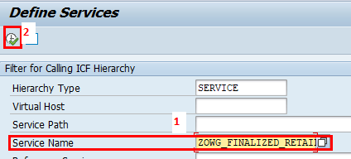

* 1. Double-click on the service name in the tree structure

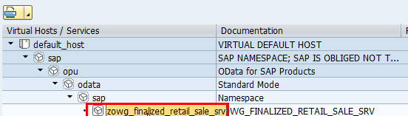

* 1. Click the change button and then click the GUI Configuration button

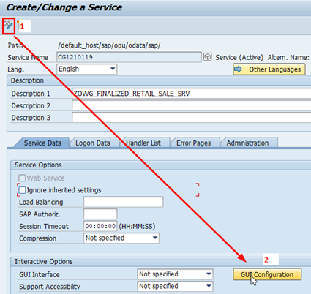

* 1. In the pop-up window enter the parameter ~CHECK_CSRF_TOKEN and set the value to 0. Click the Execute button to copy the changes.

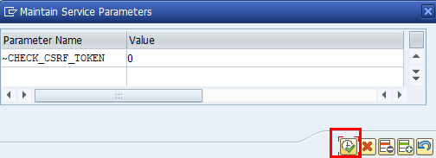

* 1. Click the Save button – Create a transport to hold your changes if you don’t have one already.

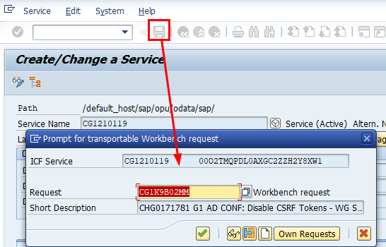

1. In your APIM API configuration, set the “request_csrf_token” value to false.

Reference the [apim-config repo document](https://github.deere.com/global-it-architecture/apim-config/blob/master/guides/api_policy.md#sap-authentication-for-odata-services) for further details.